Tutorial API

©Md@lel_Ahmed  
  
  
Step 1 : Install nm(node js) from <https://www.npmjs.com/get-npm>

Step 2 : Download API folder

Step 3 : Change your configuration in index.js file ;

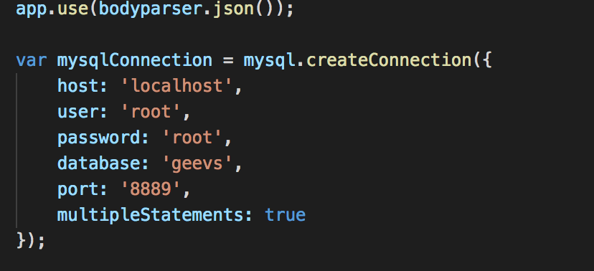

Step 4 : Add Data base using (MAMP,XAMP …)

Step 5 : Go to Api folder and Run index.js file

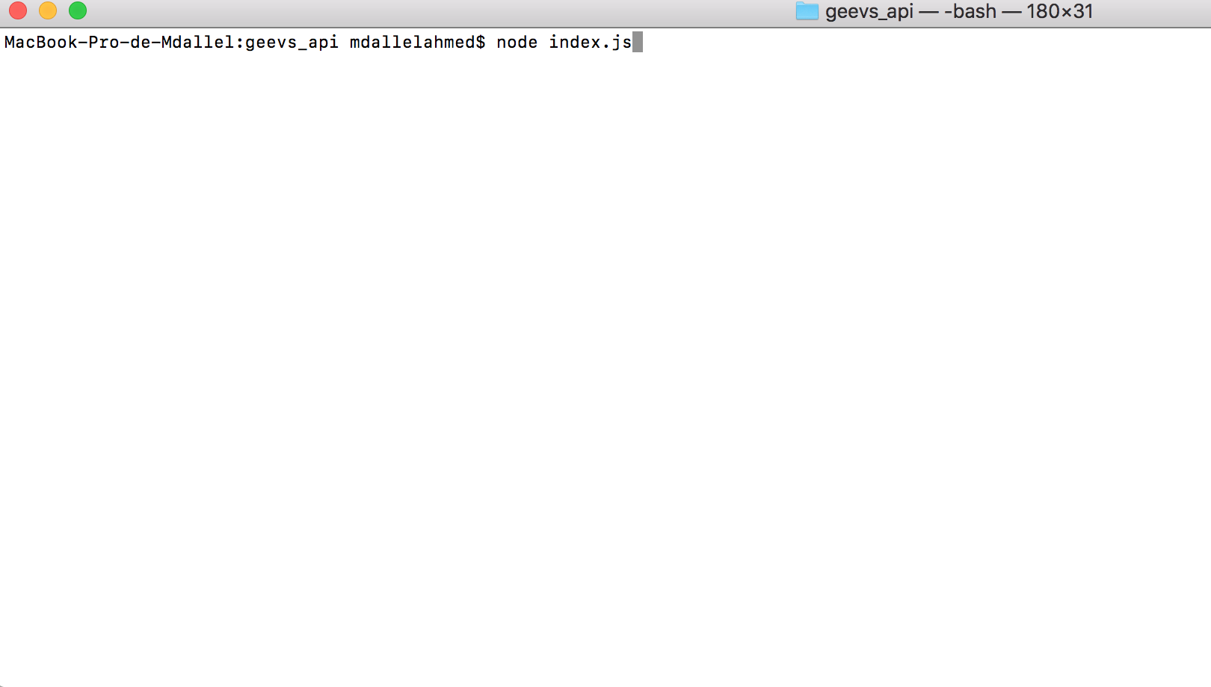

Step 6 : install Postman in your computer or using google chrome extensions

Step 7 : test your Api with postman

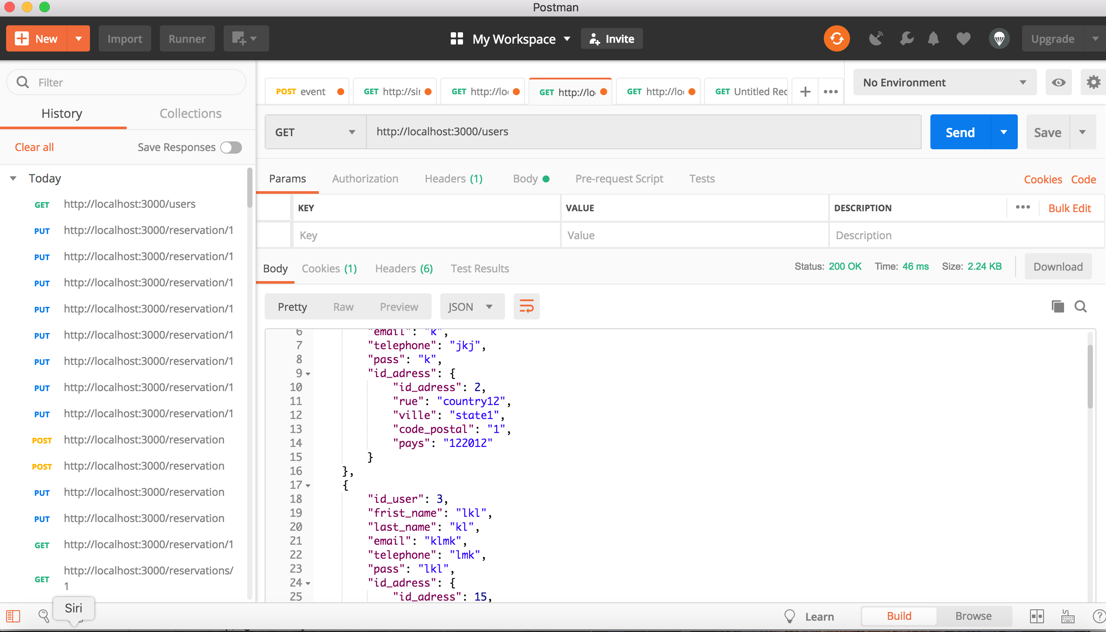  
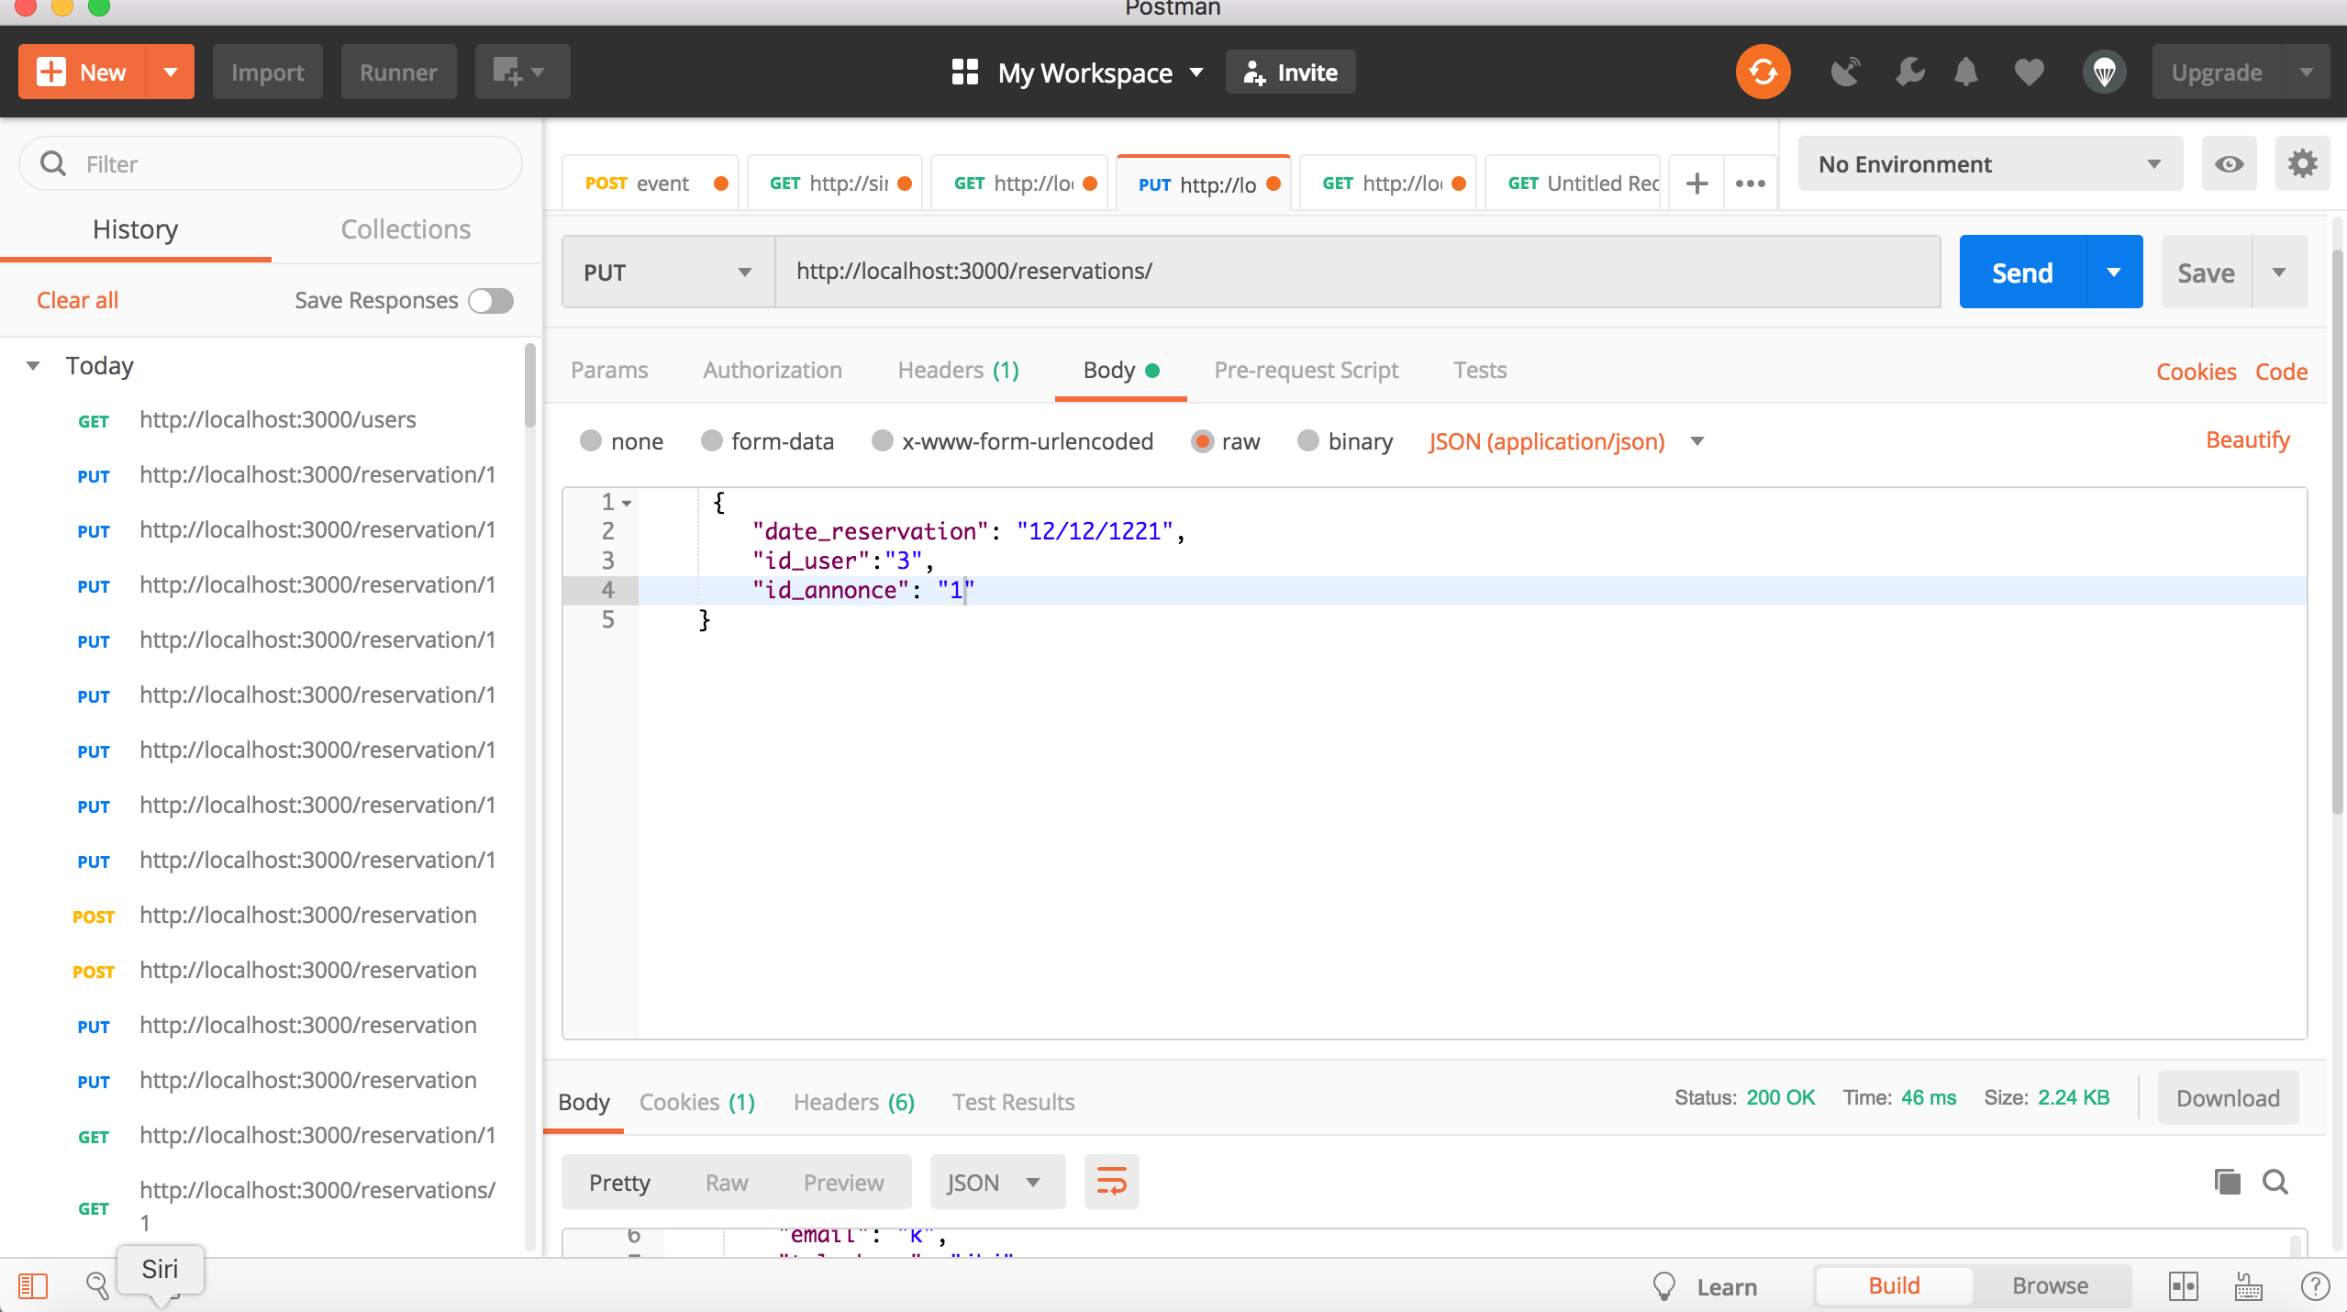

-- phpMyAdmin SQL Dump

-- version 4.8.2

-- https://www.phpmyadmin.net/

--

-- Host: localhost:8889

-- Generation Time: Dec 31, 2018 at 11:49 AM

-- Server version: 5.7.21

-- PHP Version: 7.2.7

SET SQL_MODE = "NO_AUTO_VALUE_ON_ZERO";

SET time_zone = "+00:00";

--

-- Database: `unep`

--

-- --------------------------------------------------------

--

-- Table structure for table `AirDevice`

--

CREATE TABLE `AirDevice` (

`id_device` int(11) NOT NULL,

`country` varchar(40) NOT NULL,

`state` varchar(40) NOT NULL,

`number` int(11) NOT NULL,

`date` varchar(40) NOT NULL

) ENGINE=InnoDB DEFAULT CHARSET=utf8;

--

-- Dumping data for table `AirDevice`

--

INSERT INTO `AirDevice` (`id_device`, `country`, `state`, `number`, `date`) VALUES

(1, 'country12', 'state1', 1, '122012'),

(2, '0', '0', 0, '0'),

(3, '0', '0', 0, '0'),

(5, '0', '0', 0, '0'),

(6, '0', '0', 0, '0'),

(8, '0', '0', 0, '0'),

(10, 'country1', 'state1', 1, '122012'),

(11, 'country1', 'state1', 1, '122012'),

(12, 'country1', 'state1', 1, '122012'),

(13, 'country1', 'state1', 1, '122012');

-- --------------------------------------------------------

--

-- Table structure for table `alert`

--

CREATE TABLE `alert` (

`id` int(11) NOT NULL,

`date` varchar(40) NOT NULL,

`motif` varchar(40) NOT NULL,

`user_id` int(11) NOT NULL,

`device_id` int(11) NOT NULL

) ENGINE=InnoDB DEFAULT CHARSET=utf8;

-- --------------------------------------------------------

--

-- Table structure for table `block`

--

CREATE TABLE `block` (

`indexblock` int(11) NOT NULL,

`timestamp` varchar(100) NOT NULL,

`hash` varchar(100) NOT NULL,

`previousHash` varchar(900) DEFAULT NULL,

`data` varchar(100) NOT NULL

) ENGINE=InnoDB DEFAULT CHARSET=utf8;

--

-- Dumping data for table `block`

--

INSERT INTO `block` (`indexblock`, `timestamp`, `hash`, `previousHash`, `data`) VALUES

(0, '1545296565309', '064c54e3e60b664c08ce8cab60090874195bdca680636c2e66ea70a08d66f8e9', NULL, 'First Block'),

(1, '1545296565460', '0ca6c4de8e28ecaee054429b552fd6fb1889ebfbbd341452b5584f9ece45e685', '064c54e3e60b664c08ce8cab60090874195bdca680636c2e66ea70a08d66f8e9', 'block 1'),

(2, '1545296565475', '041335bed27244cc9a90e4febf195f5c8a968fe4db1215b34728143372c48265', '0ca6c4de8e28ecaee054429b552fd6fb1889ebfbbd341452b5584f9ece45e685', 'block 2');

-- --------------------------------------------------------

--

-- Table structure for table `contact`

--

CREATE TABLE `contact` (

`id_device` int(11) NOT NULL,

`user_id` int(11) NOT NULL

) ENGINE=InnoDB DEFAULT CHARSET=utf8;

-- --------------------------------------------------------

--

-- Table structure for table `user`

--

CREATE TABLE `user` (

`user_id` int(11) NOT NULL,

`first_name` varchar(44) NOT NULL,

`last_name` varchar(44) NOT NULL,

`email` varchar(44) NOT NULL,

`password` varchar(70) NOT NULL

) ENGINE=InnoDB DEFAULT CHARSET=utf8;

--

-- Indexes for dumped tables

--

--

-- Indexes for table `AirDevice`

--

ALTER TABLE `AirDevice`

ADD PRIMARY KEY (`id_device`);

--

-- Indexes for table `alert`

--

ALTER TABLE `alert`

ADD PRIMARY KEY (`id`);

--

-- Indexes for table `block`

--

ALTER TABLE `block`

ADD PRIMARY KEY (`indexblock`);

--

-- Indexes for table `user`

--

ALTER TABLE `user`

ADD PRIMARY KEY (`user_id`);

--

-- AUTO_INCREMENT for dumped tables

--

--

-- AUTO_INCREMENT for table `AirDevice`

--

ALTER TABLE `AirDevice`

MODIFY `id_device` int(11) NOT NULL AUTO_INCREMENT, AUTO_INCREMENT=14;

--

-- AUTO_INCREMENT for table `alert`

--

ALTER TABLE `alert`

MODIFY `id` int(11) NOT NULL AUTO_INCREMENT;

--

-- AUTO_INCREMENT for table `user`

--

ALTER TABLE `user`

MODIFY `user_id` int(11) NOT NULL AUTO_INCREMENT;